We can generate Thread Dump…either J VisualVM, which Is under jdk or through command prompt using Jstack…..
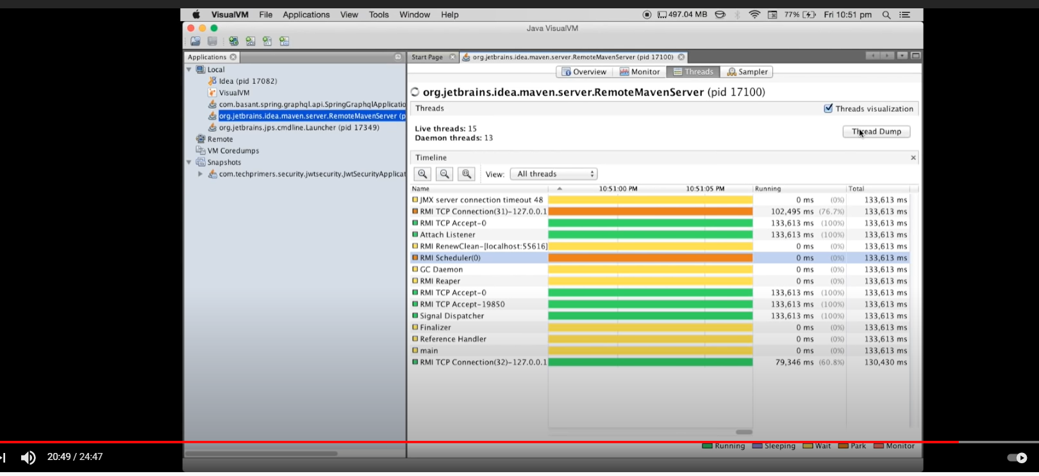

Understanding JVM Memory, Heap, Garbage Collection and Monitoring the JVM
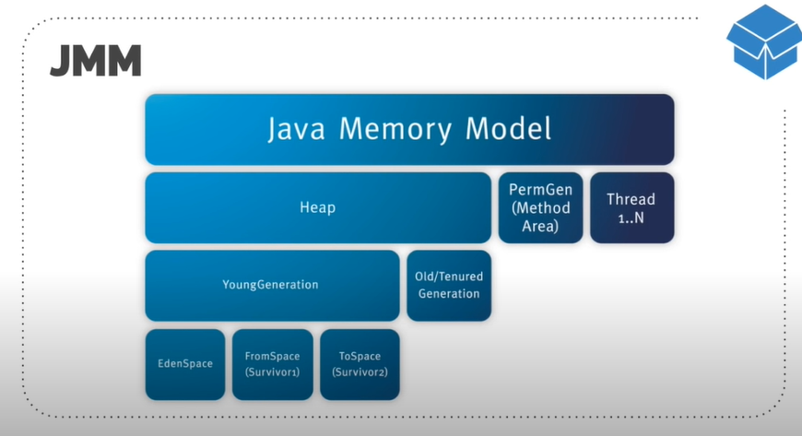
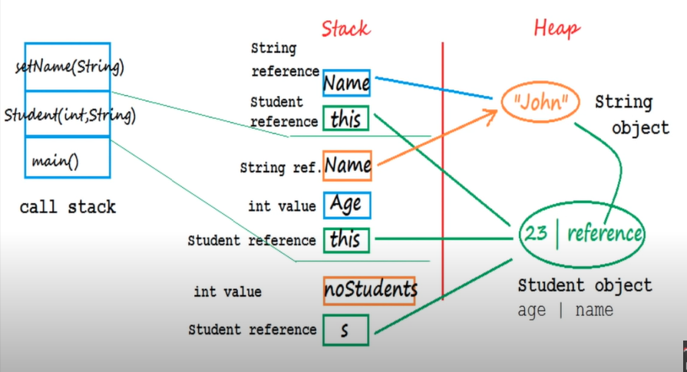

Memory Model
------------------

- Heap:- this is the place where all are primitive objects there reference are stored inside the JVM . the static variables , static objects and the ref to the class are stored inside the Heap. There is a space called Permgen which constitute the space for class loader.

- Stack:- stack is where all are local primitive variable, the local variable inside method also store in stack, the method argument also stored. Method calling flow also is there in stack.

- Method Area:- all compiled class file are stored, this method area are a part of Heap, this consist the class which is loaded by loader.

- Native Memory:- where all language specific code reside, socket connection…and all

- PC Register:- per thread 1 PC Register. Tells the thread what to do next…



There is a Heap there is a Permgen,,,there is something called Young and Old Generation inside a Heap. There are further splits up of young generation like EdenSpace, FromSpace and ToSpace….

Young Generation and Old Generation:-
Young generation is a place where all new objects which we creates go In. this resides in a Heap. And all new Objects what we create are creating inside the Young Generation. Once the Young generation filled up the garbage collection kicks in and this type of Garbage collection called the Minor Garbage collection or Minor GC. Once the object which don’t get garbage collected reside in the young generation they are moved to the Old generation. So the object which go through the life cycle of GC or lots of GC but still survived those moved to the Old generation. So that is where the long lived objects go in.
The Garbage collection which occur at old generation is called Major GC. So this will collect all objects which are not need any more.

EdenSpace:- all the new objects are inside the Eden Memory, so when eden memory filled up with the objects the minor gc get kept in and all the objects which get survived moved to Surviverspace . the objects which didn’t get GC moved to survier1 and surviver2. The minor GC also check the surviver space to ensure that the surviver space is empty. The object which survived after lots of cycle gets moved to the old generation. Usually this is done by the setting the young generation threshold….so this is the how Heap split up…different types like Young and Old Generation.

Where are the Object store inside the Heap…??

Object either can be stored in Heap or stack.


JVM is the virtual machine on which java code executes. Reference is stored into Stack or address of the Heap is store in stack. Stack store the variable.

Garbage Collection:-

Inside the Garbage Collection stepe:-



1. Marking:- As a part of Marking Garbage Collection Identify what are all objects which are not in use.
2. Normal Deletion:- as a part of the deletion or normal deletion these objects which have been identify unused will be removed from the Heap.
3. Deletion + Compacting:- final all last stage is deletion or the Compacting. Once the objects are removed from the Heap the memory allocation is random . these memory allocation are group together so the memory allocation for the future is be faster.

Garbage Collector:-

JVM provides diff types of GC…..

- Serial GC:- this can be useful when we want to mark and delete simply in the young and Old Generation.
This is useful in the client machine such as our simple stand alone application. .
And the Machine with smaller CPU.
This is not for large scale application when a lots of thread running into the Heap. That is when we can go for the Parallel GC.
This can be use when we don’t have a low pauses.

- Parallel GC:- Parallel GC are same as the Serial GC but it can go for the n number of tread running into the young and old generation.
Also called through put collector bcz it uses multiple cpu.
Parallel GC uses one thread for Old generation and multiple threads for the young generation.
This can use when we have a low pauses.

- Parallel Old GC:- this is same as Parallel GC just the concept will be both the young and Old generation will have N number of threads.

- Concurrent Mark sweep:- concurrent low pause collector.
It does the GC for the old generation only. It will try to minimize the pause which happen during the GC. We can limit the thread size for jvm. If we don’t want to pause for a long period of time go for a CMS

- G1 GC:- this introduced after java 7
Default GC for java 9
It’s a Parallel concurrent and low pause GC.
And there is no concept of young and old generation space.
It divides the space inside the Heap, into multiple equally sized the Heap regions and whenever there is a GC involved it first collects the region with the lesser lived data.

PermGen VS Metaspace:- Metaspace is new concepts from java 8.
Previously PermGen called the Method Area, now it is replace with Metaspace.

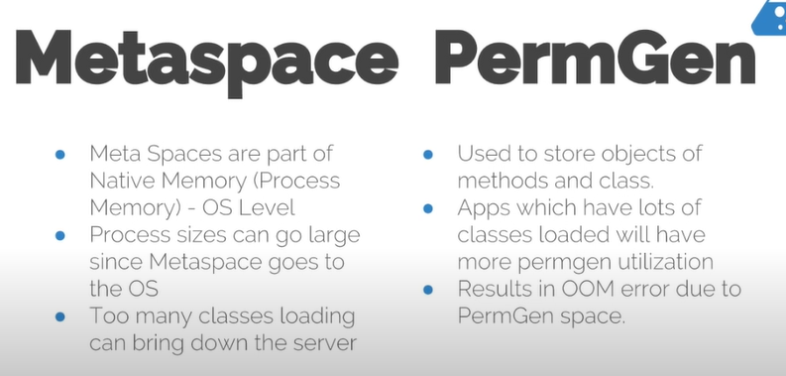

What is JVM (Java virtual machine) in java?

JVM is responsible for converting byte code into machine specific code.
HotSpot JVM (Java Virtual Machine) Architecture >
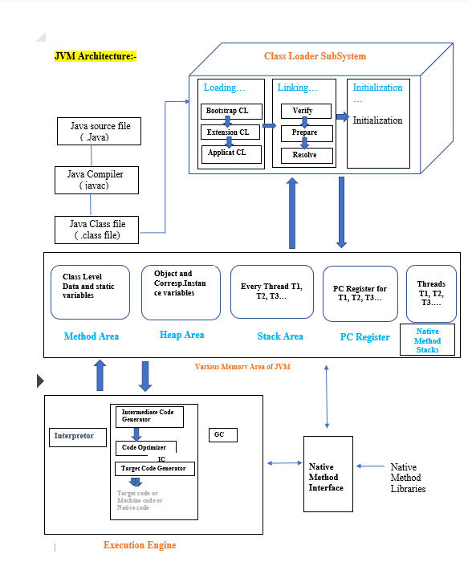
JVM (Java Virtual Machine) consists of Class Loader Subsystem, Runtime Data Areas and Execution Engine. Let’s discuss each of them in detail.

1) Class Loader Subsystem of JVM >

Classloader is a subsystem of JVM.
Classloader is used to load class files.
Classloader verifies the class file using byte code verifier. Class file will only be loaded if it is valid.

2) Runtime Data Areas of JVM >
2.1) Method Area >
Method area is also called class area.
Method area stores data for each and every class like fields, constant pool,method’s data and information.
2.2) Heap >
Heap is place where all objects are stored in JVM (java virtual machine).
Heap even contains arrays because arrays are objects.

2.3) Java Threads (Java thread Stacks) >
You must know that each and every thread has its own stack.
How stack frames are created when thread calls new method?
As we know each and every thread has its own stack. Whenever new method is called new stack frame is created and it is pushed on top of that thread's stack.

What does thread stack contains?
The stack contains
- All the local variables,
- All the parameters,
- All the return address.
Does stack stores/contains object OR what stack doesn’t contains?
Stack never stores object, but it stores object reference.

2.4) Program counter registers (PC Registers) >
Program counter registers contains >
- the address of instructions currently being executed and
- address of next instruction as well.

2.5) Native internal Threads (Native thread stack ) >
Native internal threads area contains all the informations related to native platform.
Example - If we are running JVM (java application) on windows, it will contain all information related to native platform i.e. windows.
If we are running JVM (java application) on linux, it will contain all information related to native platform i.e. linux.

3) Execution Engine of JVM >
Execution Engine contains JIT (Just In Time) Compiler and Garbage collector compiler. Execution Engine also contains Interpreter.

3.1) JIT(Just In Time) compiler >
JIT compiler compiles bytecodes to machine code at run time and improves the performance of Java applications.
JIT Compiler internal working >
JIT compilation does require processor time and memory usage. When the JVM first starts up, lots of methods are called. Compiling all of these methods might can affect startup time significantly, though program ultimately may achieve good performance.
Methods are not compiled when they are called first time. For each and every method JVM maintains a call count, which is incremented every time the method is called. The methods are interpreted by JVM until call count not exceeds JIT compilation threshold (The JIT compilation threshold improves performance and helps the JVM to start quickly. The threshold has been selected carefully by java developers to obtain an optimal performances. Balance between startup times and long term performance is maintained).
Therefore, very frequently used methods are compiled as soon as JVM has started, and less used methods are compiled_later.
How JIT improves performance of Most frequently used methods ?
After a method is compiled, its call count is reset to zero and subsequent calls to the method increment it call count. When the call count of a method reaches a JIT recompilation threshold, the JIT compiler compiles method second time, applying more optimizations as compared to optimizations applied in previous compilation. This process is repeated until the maximum optimization level is reached. Most frequently used methods are always optimized to maximize the performance benefits of using the JIT compiler.
Example -
Let’s say JIT recompilation threshold = 2
After a method is compiled, its call count is reset to zero and subsequent calls to the method increment it call count. When the call count of a method reaches a 2 (i.e. JIT recompilation threshold), the JIT compiler compiles method second time, applying more optimizations as compared to optimizations applied in previous compilation.
3.2) Garbage Collector
Garbage collection is the process by which JVM clears objects (unused objects) from heap to reclaim heap space.

Interpreter > Interpreter is responsible for reading the bytecode and then executing the instructions.

Native method libraries of JVM >
Native method interface is an interface that connects JVM with the native method libraries for executing native methods.
Example of Native method libraries>
If we are running JVM (java application) on windows, then Native method interface(window method interface) will connect JVM with the window methods libraries(native method libraries) for executing window methods (native methods).

You must know about JNI, What is Java Native Interface(JNI)?
You may write your application purely in java but there are certain situations where java code might need meet your requirement.
Programmers uses the JNI (Java Native Interface) to write the Java native methods when an application cannot be written purely in Java.

What’s role of JVM in making java a platform independent language?
Answer.
Once source code (i.e. .java file) is compiled on one platform(bytecode is formed). That bytecode can be executed (interpreted) on any other platform running a JVM.
Every platform have different JVM implementation.
Example -
JVM for windows platform is different from JVM for linux platform.

Diagram to show java is platform independent>
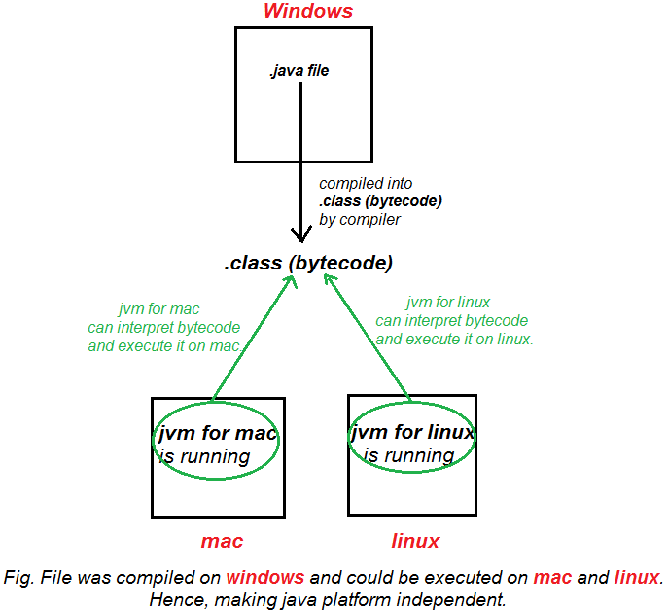

The JVM is a very powerful and flexible runtime platform for languages such as Java, Groovy, Scala and Clojure. JVM provides large number of libraries and is completely interoperable with Java.

Is JVM available in JDK?
Answer. It is very simple jvm interview question.
YES.
JDK = JRE + JVM.

Read :

Is JVM available in JRE?
Answer. YES.
JRE = JVM + class libraries (rt.jar) + other libraries (if any).

What is Differences between JDK, JRE and JVM?
Answer. It is important and simple jvm interview question. You must know about all of these in detail, don’t confuse between these terms.
1) JDK (Java Development Kit)
As the name suggests, JDK is required for java development.
You need to have JDK in your system for >
- developing,
- compiling and
- running Java programs.
In short JDK = JRE + JVM.

JDK diagram >
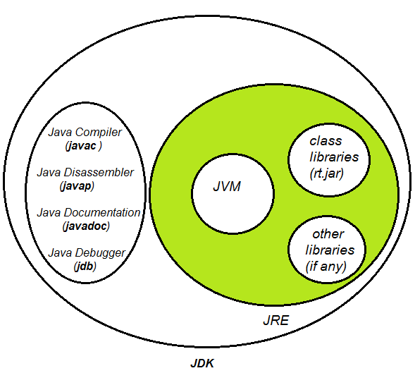

2) JRE (Java Runtime environment)
JRE provides environment for running/executing programs.
You need to have JRE in your system for >
- running Java programs.
JRE contains-
- JVM,
- class libraries (rt.jar) and
- other supporting libraries (external jars, Ex - ojdbc.jar for JDBC) for executing java program.
In short JRE = JVM + class libraries (rt.jar) + other libraries (if any).
JRE diagram >
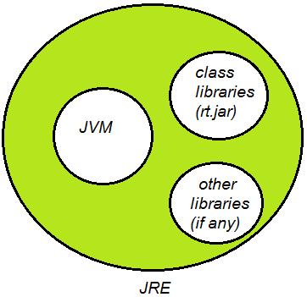

Differences between JDK, JRE and JVM

JDK | JRE | JVM
Java Development Kit | Java Runtime environment | java virtual machine
JDK is required for java development. | JRE provides environment for running/executing programs. | JVM is the virtual machine on which java code executes.  JVM is responsible for converting byte code into machine specific code.
We need JDK in your system for>  - developing,  - compiling and  - running Java programs.  JDK contains-  - JRE and  - JVM | You need to have JRE in your system for >  - running Java programs.  JRE contains-  - JVM,  - class libraries and  - other supporting libraries. | -
In short  JDK = JRE + JVM | In short  JRE = JVM + class libraries (rt.jar) + other libraries (if any).

Garbage Collection

Question 1. Where are objects created in memory? On stack or heap?
Answer. Let’s start garbage collection interview question with very basic question. All Java objects are always created on heap in java.

Question 2. What is Garbage Collection process in java?
Answer. GC (Garbage collection) is the process by which JVM cleans objects (unused objects) from heap to reclaim heap space in java.

Question 3. What is Automatic Garbage Collection in JVM heap memory in java?
Answer.
Automatic garbage collection is the process of
- Identifying objects which are in use in java heap memory and
- Which objects are not in use in java heap memory and
- deleting the unused objects in java heap memory.

Question 4. How to Identify objects which are in use in JVM heap memory in java?
Answer.
Objects in use (or referenced objects) are those objects which are still needed by java program, some part of java program is still pointing to that object.

Question 5. Which objects are not in use in JVM heap memory in java?
Answer.
Objects not in use (or unreferenced objects) are those objects which are not needed by java program, no part of java program is pointing to that object.
So, these unused objects can be cleaned in GC (garbage collection) process and memory used by an unreferenced object can be reclaimed.

Question 6. Explain JVM Heap memory (Hotspot heap structure) with diagram in java?
Answer.
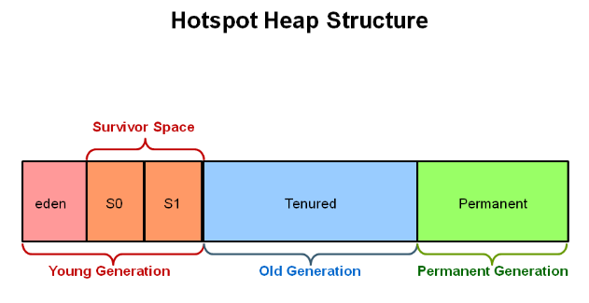

JVM Heap memory (Hotspot heap structure) in java consists of following elements>
- Young Generation
  - 1a) Eden,
  - 1b) S0 (Survivor space 0)
  - 1c) S1 (Survivor space 1)
- Old Generation (Tenured)
- Permanent Generation.

So, JVM Heap memory (Hotspot heap structure) is divided into three parts Young Generation, Old Generation (tenured) and Permanent Generation.

Young Generation is further divided into Eden, S0 (Survivor space 0) and S1 (Survivor space 1).

Question 7. What is Throughput in gc(garbage collection) in java ?
Answer.
In short, Throughput is the time not spent in garbage collection (GC) ( in percent).
Throughput focuses on maximizing the amount of work by an application in a specific period of time. Examples of how throughput might be measured include >
- The number of transactions completed in a given time.
- The number of jobs that a batch program can complete in an hour.
- The number of database queries that can be completed in an hour.

Question 8. What are pauses in gc(garbage collection) in java ?
Answer. Pauses is applications pauses i.e. when application doesn’t gives any response because of garbage collection (GC).

Question 9. What is Young Generation in JVM Heap memory in java?
Answer.
New objects are allocated in Young generation.

Young Generation consists of >
- 1a) Eden,
- 1b) S0 (Survivor space 0)
- 1c) S1 (Survivor space 1)

Young Generation is further divided into three parts Eden, S0 (Survivor space 0) and S1 (Survivor space 1).

Question 10. What is Old Generation in JVM Heap memory in java?
Answer.
The Old Generation(tenured generation) is used for storing the long surviving aged objects (Some of the objects which aren't cleaned up survive in young generation and gets aged. Eventually such objects are moved from young to old generation).

Major garbage collection occurs in Old Generation.

At what time (or what age) objects are moved from young to old generation in JVM heap?
There is some threshold set for young generation object and when that age is met, the object gets moved to the old generation.

What is major garbage collection in java? (We will read about it in detail in upcoming interview questions)
When the old generation fills up, this causes a major garbage collection. Objects are cleaned up from old generation.

Question 11. What is Permanent Generation in JVM Heap memory in java?
Answer. This is third generation in java heap and hence is very important garbage collection interview question. It is complex question and hence experienced software professionals must know it.
Permanent generation (Permgen) Space contains metadata required by JVM to describe the classes and methods used in the application.
The permanent generation is included in a full garbage collection in java.
The permanent generation space is populated at runtime by JVM based on classes in use in the application.
The permanent generation space also contains Java SE library classes and methods in java.
JVM garbage collects those classes when classes are no longer required and space may be needed for other classes in java.

Question 12. What is Minor garbage collection in JVM Heap memory in java?
Answer.

Minor garbage collection occurs in Young Generation
New objects are allocated in Young generation.
When the young generation fills up, this causes a minor garbage collection.
All the unreferenced (dead) objects are cleaned up from young generation.

When objects are moved from young to old generation in JVM heap?
Some of the objects which aren't cleaned up survive in young generation and gets aged. Eventually such objects are moved from young to old generation.

What is Stop the World Event?
Minor garbage collections are called Stop the World events.

All the non-daemon threads running in application are stopped during minor garbage collections (i.e. the application stops for while).
Daemon threads performs minor garbage collection. (Daemon threads are low priority threads which runs intermittently in background for doing garbage collection).

Question 13. What is Major garbage collection in JVM Heap memory in java?
Answer.
Major garbage collection occurs in Old Generation
The Old Generation is used for storing the long surviving aged objects.
At what time (or what age) objects are moved from young to old generation in JVM heap?
There is some threshold set for young generation object and when that age is met, the object gets moved to the old generation during garbage collection in java.

When the old generation fills up, this causes a major garbage collection. Objects are cleaned up from old generation.
Major collection is much slower than minor garbage collection in jvm heap because it involves all live objects.
Major garbage collection are Stop the World Event in java?
Major garbage collections are also called Stop the World events.
All the non-daemon threads running in application are stopped during major garbage collections.
Daemon threads performs major garbage collection.
Major garbage collections in responsive applications in java?
Major garbage collections should be minimized for responsive applications because applications must not be stopped for long.

Optimizing Major garbage collections in responsive applications in java?
Selection of appropriate garbage collector for the old generation space affects the length of the “Stop the World” event for a major garbage collection.

Question 14. What is Full garbage collection in JVM Heap memory in java?
Answer. You must be able to differentiate between garbage collection and full garbage collection. Don’t mess up between two terms.
Full garbage collection occurs in permanent generation in java
Permanent generation Space contains metadata required by JVM to describe the classes and methods used in the application.
The permanent generation space is populated at runtime by JVM based on classes in use in the application.
JVM garbage collects those classes when classes are no longer required and space may be needed for other classes in java.

Question 15. Mention some of the most important VM (JVM) PARAMETERS you have used for Young Generation in JVM Heap memory?
Answer. It is important and challenging garbage collection interview question for experienced developers to specifically identify and answer jvm parameters for young generation.

-Xmn : -Xmn sets the size of young generation.
Example of using -Xmn VM (JVM) option in java >
java -Xmn512m MyJavaProgram

-XX:NewRatio : NewRatio controls the size of young generation.
Example of using -XX:NewRatio VM option in java >
-XX:NewRatio=3 means that the ratio between the young and old/tenured generation is 1:3.

-XX:NewSize - NewSize is minimum size of young generation which is allocated at initialization of JVM.

-XX:MaxNewSize - MaxNewSize is the maximum size of young generation that JVM can use.

-XX:SurvivorRatio : (for survivor space)
SurvivorRatio can be used to tune the size of the survivor spaces, but this is often not as important for performance.
Example of using -XX:SurvivorRatio > -XX:SurvivorRatio=6 sets the ratio between each survivor space and eden to be 1:6.

Question 16. Mention some of the most important VM (JVM) PARAMETERS you have used for Old Generation (tenured) in JVM Heap memory?
Answer. Another is difficult and challenging garbage collection interview question for experienced developers to specifically identify and answer jvm parameters for old generation.

-XX:NewRatio : NewRatio controls the size of young and old generation.
Example of using -XX:NewRatio, -XX:NewRatio=3 means that the ratio between the young and old/tenured generation is 1:3.

Question 17. Mention some of the most important VM (JVM) PARAMETERS you have used for Permanent Generation?
Answer. Another difficult garbage collection interview question for experienced developers to specifically identify and answer jvm parameters for permanent generation.

-XX:PermSize: It’s is initial value of Permanent Space which is allocated at startup of JVM.
Example of using -XX:PermSize VM (JVM) option in java >
java -XX:PermSize=512m MyJavaProgram
It will set initial value of Permanent Space as 512 megabytes to JVM

-XX:MaxPermSize: It’s maximum value of Permanent Space that JVM can allot up to.
Example of using -XX:MaxPermSize VM (JVM) option in java >
java -XX:MaxPermSize=512m MyJavaProgram
It will set maximum value of Permanent Space as 512 megabytes to JVM

Question 18. What are different Garbage collectors available in JVM?
Answer.

Different type of garbage collectors in java>

Serial collector / Serial GC (Garbage collector) in java

Throughput GC (Garbage collector) or Parallel collector in java

Concurrent Mark Sweep (CMS) collector / concurrent low pause garbage collector

G1 garbage collector / Garbage first collector

Question 19 . What is Serial collector / Serial GC (Garbage collector) in java?
Answer.

Features of Serial GC (Garbage collector) in java >
- Serial collector is also called Serial GC (Garbage collector) in java.
- Serial collector is simply also called Serial collector in java.
- Serial GC (Garbage collector) is rarely used in java.
- Serial GC is designed for the single threaded environments in java.
- In Serial GC (Garbage collector) , both minor and major garbage collections are done serially by one thread in java.
- Serial GC uses a mark-compact collection method. The serial garbage collector is the default for client style machines in Java SE 5 and 6.

When to Use the Serial GC (garbage Collector) in java >
- The Serial GC is the garbage collector of choice for most applications that do not have low pause time requirements and run on client-style machines.
- Serial garbage collector is also popular in environments where a high number of JVMs are run on the same machine.

Vm (JVM) option for enabling serial GC (garbage Collector) in java >
-XX:+UseSerialGC
Example of Passing Serial GC in Command Line for starting jar>
java -Xms256m -Xms512m -XX:+UseSerialGC -jar d:\MyJar.jar

Question 20. What is Throughput GC (Garbage collector) or Parallel collector in java?
Answer. Experienced developers must know about this garbage collection interview question.

1. Features of Throughput GC (Garbage collector) in java >
- Throughput collector is also called
  - Throughput GC (garbage collector)
  - ParallelGC (garbage collector)
  - Throughput collector
  - ParallelGC collector
- Throughput garbage collector is the default garbage collector for JVM in java.
- Throughput garbage collector uses multiple threads to execute a minor collection and so reduces the serial execution time of the application in java.

2. When to Use the Throughput GC (Garbage collector) in java >
The Throughput garbage collector should be used when application can afford low pauses in java.
And application is running on host with multiple CPU’s in java.

3. Vm (JVM) option for enabling throughput GC (Garbage collector) in java >
-XX:+UseParallelGC

Example of using throughput collector in Command Line for starting jar>
java -Xms256m -Xms512m -XX:+UseParallelGC -jar d:\MyJar.jar

With this Vm (JVM) option you get a
- Multi-threaded young generation garbage collector in java,
- single-threaded old generation garbage collector in java and
- single-threaded compaction of old generation in java.

4. Goals for Throughput GC (Garbage collector) in java >
- Maximum pause time goal (Highest priority)
- Throughput goal
- Minimum footprint goal (Lowest priority)

Question 21. What is Concurrent Mark Sweep (CMS) Collector / concurrent low pause collector in java?
Answer.

1. Features of Concurrent Mark Sweep (CMS) Collector / concurrent low pause collector in java >
- Concurrent Mark Sweep Collector is also called
  - concurrent low pause collector
  - concurrent low pause GC (garbage collector)
  - CMS GC (garbage Collector)
  - CMS Collector
  - concurrent low pause collector
  - concurrent low pause GC (garbage collector)
- Concurrent Mark Sweep (CMS) collector collects the old/tenured generation in java.
- Concurrent Mark Sweep (CMS) Collector minimize the pauses by doing most of the garbage collection work concurrently with the application threads in java.
- Concurrent Mark Sweep (CMS) Collector on live objects >
Concurrent Mark Sweep (CMS) Collector does not copy or compact the live objects. A garbage collection is done without moving the live objects. If fragmentation becomes a problem, allocate a larger heap in java.

2. When to Use the Concurrent Low Pause Collector in java
- Concurrent Low Pause Collector should be used if your applications that require low garbage collection pause times in java.
- Concurrent Low Pause Collector should be used when your application can afford to share processor resources with the garbage collector while the application is running in java.
- Concurrent Low Pause Collector is beneficial to applications which have a relatively large set of long-lived data (a large tenured generation) and run on machines with two or more processors in java.

Examples when to use Concurrent Mark Sweep (CMS) collector / concurrent low pause collector should be used for >
Example 1 - Desktop UI application that respond to events,
Example 2 - Web server responding to a request and
Example 3 - Database responding to queries.

3. Vm (JVM) option for enabling Concurrent Mark Sweep (CMS) Collector in java >
-XX:+UseConcMarkSweepGC

Example of using Concurrent Mark Sweep (CMS) collector / concurrent low pause collector in Command Line for starting jar>
java -Xms256m -Xms512m -XX:+UseConcMarkSweepGC -jar d:\MyJar.jar

4. Concurrent Mark Sweep (CMS) Collector / concurrent low pause collector working in detail in java >
As mentioned above Concurrent Mark Sweep (CMS) collector collects the old/tenured generation (i.e. performs Major garbage collection process).

5. Heap Structure for CMS garbage Collector
CMS garbage collectors divides heap into three sections: young generation, old generation, and permanent generation of a fixed memory size.

Young Generation is further divided into Eden, S0 (Survivor space 0) and S1 (Survivor space 1).

5.4.6. Detailed Steps in GC (garbage collection) cycle in Concurrent Mark Sweep (CMS) Collector / concurrent low pause garbage collector in java >

Young Generation GC (garbage Collection) in java
- Live objects are copied from the Eden space and survivor space to the other survivor space.
- Any older objects that have reached their aging threshold are promoted to old generation.

After Young generation GC (garbage Collection) in java
- After a young GC, the Eden space and one of the survivor spaces is cleared.
- promoted objects (older objects that have reached their aging threshold in young GC) are are available in old generation.

Old Generation GC (garbage Collection) with CMS in java
- Initial mark phase - (First pause happens/ stop the world event ) - mark live/reachable objects (Example - objects on thread stack, static objects etc.) and elsewhere in the heap (Example - the young generation).

- Concurrent marking phase - (No pause phase ) - finds live objects while the application continues to execute.

- Remark - (Second pause happens/ stop the world events) - It finds objects that were missed during the concurrent marking phase due to the concurrent execution of the application threads.

Old Generation GC (garbage Collection) - Sweep phase (Concurrent Sweep phase) in java

- Sweep phase - do the concurrent sweep, memory is freed up.
- Objects that were not marked in the previous phase are deallocated in place.
- There is no compaction

Unmarked objects are equal to Dead Objects.

Old Generation GC (garbage Collection) - After Sweeping

- Reset phase - do the concurrent reset.

Question 23. What are Difference between Serial and Throughput gc (garbage Collector) ?
Answer.
Serial collector uses one thread to execute garbage collection.
Throughput collector uses multiple threads to execute garbage collection.

Serial GC is the garbage collector of choice for applications that do not have low pause time requirements and run on client-style machines.
Throughput GC is the garbage collector of choice for applications that have low pause time requirements.

Question 24. Which methods is called for garbage collection in java?
Answer.
Gc (garbage collector) calls finalize method for garbage collection.
finalize method is called only once by garbage collector for an object in java.
finalize method is in java.lang.Object class.

Program to call System.gc() method in Java >
public class RunGarbageCollectorExample {
public static void main(String[] args) {
System.out.println("About to call garbage collection - using System.gc() method");
System.gc();
System.out.println("garbage collection - using System.gc() method called");
}
}
/*OUTPUT
About to call garbage collection - using System.gc() method
garbage collection - using System.gc() method called
*/

Question 25. Can we force early garbage collection in java?
Answer.
Yes it is possible to force early garbage collection in java. But how?

We can force early gc (garbage collection) in java by using following methods >
System.gc();
Runtime.getRuntime().gc();

System.runFinalization();
Runtime.getRuntime().runFinalization();

Question 26. Is it good practice to call System.gc() in Java?
Answer. Answer in short is No, but let’s learn why we must not call System.gc() in java >
- First of all calling System.gc() does not guarantee that it will immediately start performing garbage collection.
- Even calling System.gc() may not do anything. Call to perform garbage collection may be ignored completely.
- JVM is different for different platforms because java is platform independent language, so you never know about which garbage collector your jvm will run i.e. what algorithm does it follow to perform garbage collection.

Question 27. Is garbage collection guaranteed when we call finalize() methods?
Answer. Answer in short is No.
By calling finalize method JVM runs the finalize() methods of any objects pending finalization i.e. objects which have been discarded but there finalize method is yet to be run. After finalize method is executed JVM reclaims space from all the discarded objects in java.

Calling finalize methods does not guarantee that it will immediately start performing garbage collection.

Finalize method execution is not assured - We must not override finalize method to write some critical code of application because methods execution is not assured. Writing some critical code in finalize method and relying on it may make application to go horribly wrong in java.

Question 28. Which thread performs garbage collection in java?
Answer.
Daemon threads are low priority threads which runs intermittently in background for doing garbage collection (gc) in java.

Question 31. How garbage collection is done using Marking and deletion in java?
Answer. It is very very important garbage collection interview question for all java developers.
1) Marking
Marking is a process in which gc (garbage collector) identifies which parts of memory (occupied by objects) are in use and which are not.
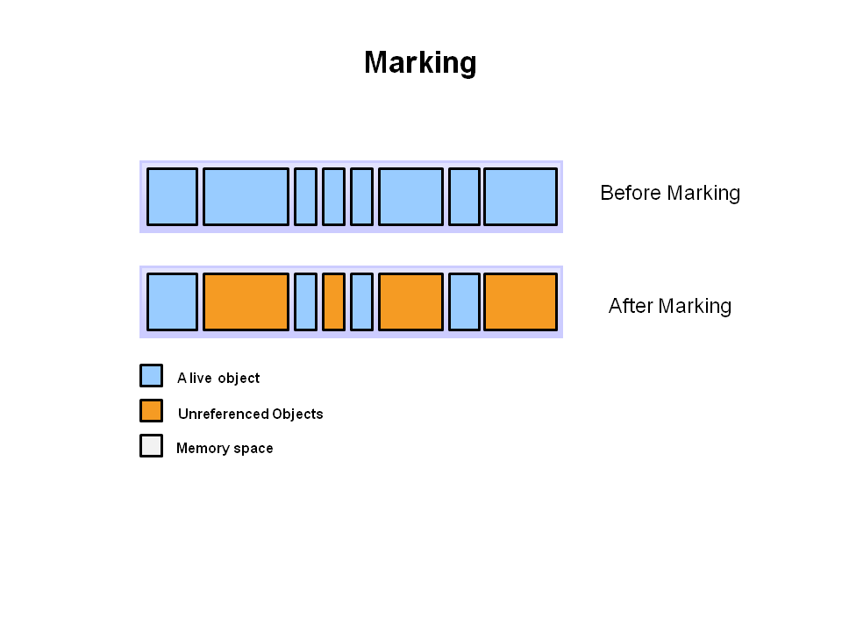
Before Marking >
All the objects are shown in blue, at this stage
- some of objects might be in use (referenced objects) and
- some of objects might not be in use (unreferenced objects) .
After Marking >
Objects in use (or referenced objects or Alive objects) are shown in blue.
Objects not in use (or unreferenced objects) objects are shown in Orange.

2) Deletion
Step 2a : Normal Deletion
- Normal deletion removes all the unreferenced objects and
- leaves referenced objects and pointers to free space.
Step 2b : Deletion with Compacting
Deletion with Compacting is done to improve the performance than normal deleting.
- Deletion with Compacting removes all the unreferenced objects and
- compacts the remaining referenced objects by moving all the referenced objects together.

Question 32. Mention how to use different garbage collectors by passing vm parameters in java?
Answer. It is very important to know how to use different garbage collectors by passing vm parameters.

1) Vm (JVM) option for enabling serial GC (garbage Collector) in java >
-XX:+UseSerialGC
Example of Passing Serial GC in Command Line for starting jar>
java -Xms256m -Xms512m -XX:+UseSerialGC -jar d:\MyJar.jar

2) Vm (JVM) option for enabling throughput GC (Garbage collector) in java >
-XX:+UseParallelGC

Or (throughput collector with n number of threads)
-XX:ParallelGCThreads=<numberOfThreads>
Or
-XX:+UseParallelOldGC

3) Vm (JVM) option for enabling Concurrent Mark Sweep (CMS) Collector in java >
-XX:+UseConcMarkSweepGC

Or (CMS garbage collector with n number of threads)
-XX:ParallelCMSThreads=<n>

4) Vm (JVM) option for enabling G1 Garbage Collector
-XX:+UseG1GC

Question 33. Can you make objects eligible for garbage collection in java?
Answer.
Yes, we can make object explicitly eligible for garbage collection.
Object which is set explicitly set to null becomes eligible for gc (garbage collection) in java .
Example 1 >
String s=”abc”; //s is currently not eligible for gc (garbage collection) in java.
s = null; //Now, s is currently eligible for gc (garbage collection) in java.

Example 2 >
List list =new ArrayList(); //list is currently not eligible for gc (garbage collection).
list = null; //Now, list is currently eligible for gc (garbage collection).

Question 34. What is Difference in garbage collection in C/C++ and Java (Hint : In terms of memory allocation and deallocation of objects)?
Answer.
In java garbage collection (memory allocation and deallocation of objects) is an automatic process.
But, In C and C++ memory allocation and deallocation of objects) is a manual process.

Question 35. Does variables declared inside block becomes eligible for gc (garbage collection) when we exit that block in java?
Answer. Yes, All the variables declared inside block becomes eligible for gc (garbage collection) when we exit that block (As scope of those variable is only that block) in java.

Example of garbage collection while using block in java -

class MyClass {
public static void main(String[] args) {
boolean var = false;
if (var) { // begin block 1
int x = 1; // x is declared inside block
//..........
//code inside block...
//..........
} // end block 1 //And now x is eligible for gc (garbage collection)
else { // begin block 2
int y = 1;
//..........
//code inside block...
//..........
} // end block 2 //And now y is eligible for gc (garbage collection)
}
}

Question 37. What is monitoring and analyzing the garbage collection in java?
Answer.
Monitoring and analyzing garbage collection in java can be used to get following information >
- Understanding the garbage collection process.
- Understanding how JVM is currently working.
- What type of garbage collection algorithms are used
- Improving garbage collection performance,
- Analyzing Java heap dumps,
- Monitoring live Java applications,
- Analyze profiling data,
- Detecting Memory leak for classes and arrays,
- Detecting Thread deadlock,
- Detecting abnormal thread termination,
- Detecting outOfMemoryError problems,
- Finding System and process CPU utilization thresholds,
- Find Heap usage thresholds.
- Find time taken in Garbage collection and Finalizer queue length.

Question 38. How to monitor and analyze the garbage collection in java ?
Answer. This is in continuation to above garbage collection interview question. We can use different tools to generate the garbage collection information and then analyze it.
1. VisualVM -
VisualVM is most popular way to generate Thread Dump and is most widely used by developers. It helps us in analyzing threads performance, thread states, CPU consumed by threads etc.
2. JSTACK - Java stack traces
jstack is very easy way to generate Thread dump and is widely used by developers.
3. -verbose:gc VM argument
4. Jstat - Java Virtual Machine Statistics Monitoring Tool
“The jstat command displays performance statistics for an instrumented Java HotSpot VM. The target JVM is identified by its virtual machine identifier, or vmid option.”
5. JHAT - Java Heap Analysis Tool.
- jconsole - jconsole option can be used to obtain a heap dump.
- hprof
- eclipse plugin
- HPjmeter
- JFR (Java Flight Recorder) can be used for detecting memory leak.

Question 39. What is memory leak in java? Consequences of memory leak?
Answer. It is must know question especially for experienced developers, freshers must at least have little information on it.

Memory leak happens when number of objects(these objects are not needed) created becomes large and time spent in garbage collection increases.

Ultimately application becomes very slow, non responsive and ends up throwing OutOfmemoryError.

“Memory leaks ends up throwing OutOfmemoryError but OutOfmemoryError doesn’t means memory leak in java”.

Consequences of memory leak >
- Application becomes very slow.
- Time spent in garbage collection increases.

Question 40. Can you please explain some scenarios where you have faced memory leak, OR scenarios where memory leak could happen in java?
Answer. It is must know question for experienced developers, 3 to 5 years developers must know at least three scenarios and 5 years+ developes must know at least 5 scenarios. And for software architects this count must be eight.
Here I have mentioned summary of memory leak points, for detail on each of these points, please refer Detecting and fixing memory leak in java

Scenarios where memory leak can happen in java >
1) Static variables/ fields are not garbage collected and can cause memory leak in java >

Static variables are only garbage collected when the class loader which has loaded the class in which static field is there is garbage collected.
So, be cautious as these static variables can create a memory leak in java.

2) Thread Local Variables can cause memory leak in java >
A thread local variable is member field in the Thread class. Such thread local variable can be used to hold the thread state.
But, thread local variable aren’t garbage collector till thread is alive.

3) Memory leak while using Autoboxing and unboxing in java >
For addition of numbers we must prefer to use primitive data type, not the Object wrapper class. Addition of numbers using Integers turns out into very costly operation in terms of performance, boxing/unboxing and unnecessary object formations.
Just imagine a situation where 1000000’s... of number are being added using Integer, it will literally explode our heap memory and boxing/unboxing operations will have adverse effect on performance.

4) Avoid memory leak using WeakHashMap in java
An entry in a WeakHashMap will be automatically removed by garbage collector when its key is no longer in ordinary use. So, using WeakHashMap in place of HashMap can help us in avoiding memory leaks.

5) Using custom key in map without Overriding equals() and hashCode() method can cause memory leak >
If custom key is used and equals() and hashCode() method are not overridden then, key will not be retrieved by using get() method.
Because get() method internally calls equals() and hashCode() method for retrieving keys.
So, these keys will neither be used nor be garbage collected, so it’s a clear case of memory leak.

So, to avoid memory leak while using custom key you must always
- Override equals() and hashCode() method
Learn how you can use custom key (Employee object) in custom HashMap Custom implementation - put, get, remove

So, to avoid memory leak you must try use String, Integer, Long, Double, Float, Short and any other wrapper class as key in HashMap.

6) Close JDBC Statement, PreparedStatement, CallableStatement , ResultSet and Connections in java to avoid memory leaks >
You must ensure that you close all the JDBC Statement, PreparedStatement, CallableStatement , ResultSet and Connections in java to avoid memory leaks. You must always close all the above mentioned objects in finally block in java because finally block is always executed irrespective of exception is thrown or not by java code.

7) Memory leaks can also be caused by native methods in java > Memory allocated through native methods can cause some serious memory leak.
8) Memory leak in web applications in java >
Unused Objects stored in application scope are memory leak because they are not collected until web application is stopped.

Question 41. Comment on relation between OutOfMemoryError and garbage collection in java?
Answer. There is huge relationship between OutOfMemoryError and garbage collection in java.

OutOfMemoryError may be thrown when an excessive amount of time is being by jvm in performing garbage collection and very little memory is being freed.

A long lived application might be unintentionally holding references to objects and this prevents the objects from being garbage collected. Holding of objects for a long time is also a kind of memory leak in java.

Question 42. Discuss OutOfMemoryError: GC Overhead limit exceeded in java?
Answer. OutOfMemoryError: GC Overhead limit exceeded - indicates that the garbage collector is running all the time and Java program is making very slow progress.

After a GC (garbage collection), if the garbage collector is spending more than 98% of its time in doing garbage collection and if less than 2% of the java heap memory space is reclaimed, then OutOfMemoryError - GC Overhead limit exceeded - is thrown in java.

This OutOfMemoryError is generally thrown because all the live objects are not getting garbage collected properly and java heap space is not available for new objects.

Question 43. What you know about OutOfMemoryError: permgen in java?
Answer. Another tricky and important garbage collection interview question which will check your in depth knowledge about jvm and garbage collection. Generally when we are facing java.lang.OutOfMemoryError - Java permgen space, then we need to change permgen size of tomcat or eclipse or JVM wherever you are facing this error.

Question 45. How to Solve OutOfMemoryError : Java heap space by passing appropriate jvm parameter?
Answer. A
OutOfMemoryError : Java heap space - is thrown whenever there is insufficient space to allocate an object in the Java heap.

Does Exception in thread threadName - java.lang.OutOfMemoryError - Java heap space indicates memory leak?
No, this OutOfMemoryError does not necessarily means that it is memory leak.

Increase the heap size using -Xms and -Xmx jvm parameters as a solution to this issue.

Question 46. How to set appropriate heap size in eclipse in java?
Answer. We can make changes in eclipse.ini file.
Where we can configure
- -Xms (minimum heap size which is allocated at initialization of JVM),
- -Xmx (maximum heap size that JVM can use. )

- -XX:MaxPermSize: It’s maximum value of Permanent Space that JVM can allot up to.

Question 47. What is default garbage collectors for Java 7?
Answer. Another very important garbage collection interview question for all developers.
default garbage collector for Java 7 >
For server class machine - parallel collector.
For client class machine - serial collector.

Question 48. What is default garbage collectors for Java 8 ?
Answer.
What is default garbage collector for Java 8 >
For server class machine - parallel collector.
For client class machine - serial collector.

Question 49. What is default garbage collectors for Java 9?
Answer. Another very important garbage collection interview question for experienced developers.

default garbage collector for Java 9 >
G1 garbage collector

interview Question 50. Throw some light on garbage collection and WeakHashMap in java?
Answer. Another very tricky garbage collection interview question for experienced developers in java.

java.util.WeakHashMap is hash table based implementation of the Map interface, with weak keys.
An entry in a WeakHashMap will be automatically removed by garbage collector when its key is no longer in ordinary use. Mapping for a given key will not prevent the key from being discarded by the garbage collector, (i.e. made finalizable, finalized, and then reclaimed). When a key has been discarded its entry is removed from the map in java.

java.util.WeakHashMap is implementation of the java.util.Map interface in java.

The behavior of the java.util.WeakHashMap class depends upon garbage collector
The behavior of the WeakHashMap class depends upon garbage collector in java. Because the garbage collector may discard keys at any time, in WeakHashMap it may look like some unknown thread is silently removing entries.
Each key object in a WeakHashMap is stored indirectly as the referent of a weak reference. Therefore a key will be removed automatically only after the weak references to it, both inside and outside of the map, have been cleared by the garbage collector.

What is JVM (Java virtual machine) in java?
JVM is the virtual machine on which java code executes.

How to set, change, increase or decrease heap size in tomcat server and eclipse to avoid OutOfMemoryError ?
1) When to change heap size in tomcat server?
Generally when we are facing java.lang.OutOfMemoryError - Java heap space then we need to change heap of tomcat.
2) How to set or change heap size in tomcat server?
For setting, changing, increasing or decreasing heap size in tomcat server you need to make changes values in the Tomcat Catalina start file. Change CATALINA_OPTS option in the file.
It will help us in avoiding avoiding java.lang.OutOfMemoryError - Java heap space

3) Where is exactly catalina.bat file located in windows?
tomcatServerHome\bin\catalina.bat
4) Where is exactly catalina.bat file located in linux/ Mac OS?
tomcatServerHome\bin\catalina.sh

5) How to change heap size in tomcat server in windows, linux and Mac platform >

5.1) How to change heap size in tomcat server in windows platform >
Open or create setenv.bat file (Location of setenv.bat file is tomcatServerHome\bin\setenv.bat)
set CATALINA_OPTS=-server -Xms512m -Xmx1024m -XX:PermSize=512m -XX:MaxPermSize=1024m
Best practices while setting heap size in tomcat server in windows platform >
You should not modify tomcatServerHome\bin\catalina.bat. You should create a new file in tomcatServerHome\bin\setenv.bat to keep your custom environment configurations separate from default tomcat server configurations.

5.2) How to change heap size in tomcat server in Linux platform >
Open or create setenv.sh file (Location of setenv.bat file is tomcatHome\bin\setenv.sh)
export CATALINA_OPTS="$CATALINA_OPTS=-server -Xms512m -Xmx1024m -XX:PermSize=512m -XX:MaxPermSize=1024m

Best practices while setting heap size in tomcat server in linux platform >
You should not modify tomcatServerHome\bin\catalina.sh. You should create a new file in tomcatServerHome\bin\setenv.sh to keep your custom environment configuartions seperate from defult tomcat server configurations.

5.3) How to change heap size in tomcat server in Mac OS platform >
Open or create setenv.sh file (Location of setenv.bat file is tomcatHome\bin\setenv.sh)
export CATALINA_OPTS="$CATALINA_OPTS=-server -Xms512m -Xmx1024m -XX:PermSize=512m -XX:MaxPermSize=1024m"
Best practices while setting heap size in tomcat server in Mac OS platform >
You should not modify tomcatServerHome\bin\catalina.sh. You should create a new file in tomcatServerHome\bin\setenv.sh to keep your custom environment configuartions seperate from defult tomcat server configurations.

6) You may use following VM (JVM) PARAMETERS to set up heap memory >
Read: How to write java program to pass VM parameters through CMD
Learn how to pass vmargs (VM parameters) to java program in eclipse?
-Xms : Xms is minimum heap size which is allocated at initialization of JVM.
Examples of using -Xms VM (JVM) option in java >
Example1 of using -Xms VM (JVM) option in cmd in java >
java -Xms512m MyJavaProgram
It will set the minimum heap size of JVM to 512 megabytes.
Example2 of using -Xms VM (JVM) option in cmd in java >
java -Xms1g MyJavaProgram
It will set the minimum heap size of JVM to 1 gigabyte.
-Xmx : Xmx is the maximum heap size that JVM can use.
Examples of using -Xmx VM option in java >
Example1 of using -Xmx VM (JVM) option in cmd in java >
java -Xmx512m MyJavaProgram
It will set the maximum heap size of JVM to 512 megabytes.
Example2 of using -Xmx VM (JVM) option in cmd in java >
java -Xmx1g MyJavaProgram
It will set the maximum heap size of JVM to 1 gigabyte.
What is the maximum heap size value you can set on your system, if you aren’t sure about the system configurations?
Try out for -Xmx:256m, if it works then try -Xmx:512m, if it works then try -Xmx:1024m and so on. Be cautious before going beyond 8g.

OutOfMemoryError in java in lots of detail

1) Different types of java.lang.OutOfMemoryError >
Exception in thread: java.lang.OutOfMemoryError: Java heap space
Exception in thread: java.lang.OutOfMemoryError: GC Overhead limit exceeded
Exception in thread: java.lang.OutOfMemoryError: Requested array size exceeds VM limit
Exception in thread: java.lang.OutOfMemoryError: Metaspace
Exception in thread: java.lang.OutOfMemoryError: request size bytes for reason. Out of swap space?
Exception in thread: java.lang.OutOfMemoryError: Compressed class space
Exception in thread: java.lang.OutOfMemoryError: reason stack_trace_with_native_method
Out of memory:Kill process or sacrifice child
Exception in thread : java.lang.OutOfMemoryError: permgen

java.lang.OutOfMemoryError is the commonly a indication of a memory leak in java.
Now, let’s discuss all of them in detail.

Before learning in detail about OutOfMemoryError in java, we must know about JVM Heap memory (Hotspot heap structure). Let's learn about heap in just 1 minute.

JVM Heap memory (Hotspot heap structure) with diagram in java >
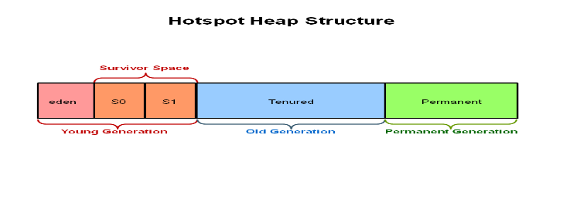
JVM Heap memory (Hotspot heap structure) in java consists of following elements>
- Young Generation
  - 1a) Eden,
  - 1b) S0 (Survivor space 0)
  - 1c) S1 (Survivor space 1)
- Old Generation (Tenured)
- Permanent Generation.

Learn this in more detail here : JVM Heap memory (Hotspot heap structure), What are Young, Old (tenured) and Permanent Generation, Minor, Major and Full garbage collection in JVM

2) Scenarios where OutOfMemoryError may be thrown >
- Usually whenever there is insufficient space to allocate an object in the Java heap OutOfMemoryError is thrown.

- What happens when there is insufficient space to allocate an object in the Java heap > The garbage collector is unable make some space available to accommodate a new object, and even the java heap cannot be expanded to create new object. (See how to adjust heap size using -Xms and -Xmx jvm parameters)

- OutOfMemoryError may also be thrown when there is insufficient native memory to support the loading of a Java class.

- OutOfMemoryError may also be thrown when an excessive amount of time is being by jvm in performing garbage collection and very little memory is being freed.

- OutOfMemoryError exception can also be thrown by native library code when a native allocation cannot be satisfied (Example - if swap space is low).

3) OutOfMemoryError: Java heap space

3.1) Exception in thread thread_name java.lang.OutOfMemoryError: Java heap space in java

OutOfMemoryError : Java heap space - is thrown whenever there is insufficient space to allocate an object in the Java heap.

Is Exception in thread threadName - java.lang.OutOfMemoryError - Java heap space
Indicates memory leak?
No, this OutOfMemoryError does not necessarily means that it is memory leak.

3.2) How to solve Exception in thread thread_name java.lang.OutOfMemoryError - Java heap space in java?
You may need to increase the heap size using -Xms and -Xmx jvm parameters as a solution to this issue.

2.1) What is -Xms JVM parameter in java?
-Xms : Xms is minimum heap size which is allocated at initialization of JVM in java.

Examples of using -Xms VM (JVM) option in java >

Example1 of using -Xms VM (JVM) option in java >
java -Xms512m MyJavaProgram
It will set the minimum heap size of JVM to 512 megabytes.

2.2) What is -Xmx JVM parameter in java?
-Xmx : Xmx is the maximum heap size that JVM can use.

Examples of using -Xmx VM option in java >
Example1 of using -Xmx VM (JVM) option in java >
java -Xmx512m MyJavaProgram
It will set the maximum heap size of JVM to 512 megabytes.

3.3) OutOfMemoryError may also be thrown in java when >
OutOfMemoryError may also be thrown when an excessive amount of time is being by jvm in performing garbage collection and very little memory is being freed.

A long lived application might be unintentionally holding references to objects and this prevents the objects from being garbage collected. Holding of objects for a long time is also a kind of memory leak in java.

Also one of the most important source of OutOfMemoryError ( Java heap space) could be the excessive use of finalizers in the application.

What happens with the excessive use of finalizers in the application?
If a class has a finalize method, then space for object is not reclaimed at garbage collection time. Instead the objects are queued for finalization after garbage collection, finalization occurs at some later time.

3.4) How excessive use of finalizers could cause OutOfMemoryError in java?
finalizers are executed by a daemon threads. As we discussed above that finalization occurs at some later time. Holding finalizer daemon threads for long time could fill the Java heap and cause OutOfMemoryError.

3.5) Example/Program in java to generate OutOfMemoryError: Java heap space >
Before executing program pass this vm parameter in eclipse.
-Xmx5m (Here maximum heap memory set to just 5 megabytes, so that we could easily produce OutOfMemoryError: Java heap space)

package outofmemory;
import java.util.ArrayList;
import java.util.List;
/**
*
* Write a program which could throw
* java.lang.OutOfMemoryError : Java Heap Space
*
*/
public class OutOfMemoryErrorJavaHeapSpace {
static List<String> list=new ArrayList();
public static void main(String[] args) {
while(true){
list.add(new String("a")); //Line 16
}
}
}

OUTPUT of program >
Exception in thread "main" java.lang.OutOfMemoryError: Java heap space
at java.util.Arrays.copyOf(Unknown Source)
at java.util.Arrays.copyOf(Unknown Source)
at java.util.ArrayList.grow(Unknown Source)
at java.util.ArrayList.ensureExplicitCapacity(Unknown Source)
at java.util.ArrayList.ensureCapacityInternal(Unknown Source)
at java.util.ArrayList.add(Unknown Source)
at outofmemory.OutOfMemoryErrorJavaHeapSpace.main(OutOfMemoryErrorJavaHeapSpace.java:16)
The solution is simply to increase the Xmx parameter to -Xmx512m as we discussed above.

4) OutOfMemoryError: GC Overhead limit exceeded
4.1) Exception in thread threadName - java.lang.OutOfMemoryError: GC Overhead limit exceeded in java
OutOfMemoryError: GC Overhead limit exceeded - indicates that the garbage collector is running all the time and Java program is making very slow progress.

After a GC (garbage collection), if the garbage collector is spending more than 98% of its time in doing garbage collection and if less than 2% of the java heap memory space is reclaimed, then OutOfMemoryError - GC Overhead limit exceeded - is thrown in java.

This OutOfMemoryError is generally thrown because all the live objects are not getting garbage collected properly and java heap space is not available for new objects.

4.2) How to avoid OutOfMemoryError - GC Overhead limit exceeded in java?
You must increase the heap size to avoid OutOfMemoryError - GC Overhead limit exceeded in java as a solution to this issue..

4.3) How to turn off OutOfMemoryError - GC Overhead limit exceeded in java?
You can turn it off by using VM (JVM) argument -XX:-UseGCOverheadLimit

4.4) Example/Program in java to generate OutOfMemoryError: GC Overhead limit exceeded >

Before executing program pass this vm parameter in eclipse.
-Xmx4m -XX:+UseParallelGC (so that we could easily produce OutOfMemoryError: GC Overhead limit exceeded)

package outofmemory;
import java.util.ArrayList;
import java.util.List;
/**
*
* Write a program which could throw
* java.lang.OutOfMemoryError : GC Overhead limit exceeded
*
*/
public class OutOfMemoryErrorGCoverheadLimitExceeded {
static List<String> list=new ArrayList();
public static void main(String[] args) {
while(true){
list.add(new String("a")); //Line 16
}
}
}

OUTPUT of program >
Exception in thread "main" java.lang.OutOfMemoryError: GC overhead limit exceeded
at outofmemory.OutOfMemoryErrorGCoverheadLimitExceeded.main(OutOfMemoryErrorGCoverheadLimitExceeded.java:16)

The solution is simply to increase the Xmx parameter to -Xmx512m as we discussed above.

12) Exception in thread threadName : java.lang.OutOfMemoryError: permgen
12.1) When you are facing OutOfMemoryError: permgen you need to change permgen size in tomcat server?
Generally when we are facing java.lang.OutOfMemoryError - Java permgen space, then we need to change permgen size of tomcat or eclipse or JVM wherever you are facing this error.
12.2) How to set or change permgen size in tomcat server?
For setting permgen size in tomcat server you need to make changes values in the Tomcat Catalina start file. Change CATALINA_OPTS option in the file.
12.3) Where is exactly catalina.bat file located?
tomcatServerHome\bin\catalina.bat
12.4) How to set permgen size in tomcat server in windows, linux and Mac platform >
12.4.1) How to set permgen size in tomcat server in windows platform >
Open or create setenv.bat file (Location of setenv.bat file is tomcatHome\bin\setenv.bat)
set CATALINA_OPTS=-server -Xms512m -Xmx1024m -XX:PermSize=512m -XX:MaxPermSize=1024m

Best practices while setting permgen size in tomcat server in windows platform >
You should not modify tomcatServerHome\bin\catalina.bat. You should create a new file in tomcatServerHome\bin\setenv.bat to keep your custom environment configurations separate from default tomcat server configurations.
5) You may use following VM (JVM) PARAMETERS to set up permgen memory (or permanent generation or permanent space) >
-XX:PermSize: It’s is initial value of Permanent Space which is allocated at startup of JVM.

Example1 of using -XX:PermSize VM (JVM) option in cmd in java >
java -XX:PermSize=512m MyJavaProgram
It will set initial value of Permanent Space as 512 megabytes to JVM

Example2 of using -XX:PermSize VM (JVM) option in java >
java -XX:PermSize=1g MyJavaProgram
It will set initial value of Permanent Space as 512 gigabyte to JVM

-XX:MaxPermSize: It’s maximum value of Permanent Space that JVM can allot up to.

Examples of using -XX:MaxPermSize VM option in java >

Example1 of using -XX:MaxPermSize VM (JVM) option in cmd in java >
java -XX:MaxPermSize=512m MyJavaProgram
It will set maximum value of Permanent Space as 512 megabytes to JVM

Example2 of using -XX:MaxPermSize VM (JVM) option in java >
java -XX:MaxPermSize=1g MyJavaProgram
It will set maximum value of Permanent Space as 1 gigabyte to JVM

What is the maximum perm gen size value you can set on your system, if you aren’t sure about the system configurations?
Try out for -XX:MaxPermSize=256m, if it works then try -XX:MaxPermSize=512m, if it works then try -XX:MaxPermSize=1024m and so on. Be cautious before going beyond 8g.

ADVERTISING

Important Points About Garbage Collector
- It is controlled by a thread known as Garbage Collector.
- Java provides two methods System.gc() and Runtime.gc() that sends request to the JVM for garbage collection. Remember, it is not necessary that garbage collection will happen.
- Java programmer are free from memory management. We cannot force the garbage collector to collect the garbage, it depends on the JVM.
- If the Heap Memory is full, the JVM will not allow to create a new object and shows an error java.lang.OutOfMemoryError.
- When garbage collector removes object from the memory, first, the garbage collector thread calls the finalize() method of that object and then remove.

JSTACK - Thread dumps - Generating and analyzing Thread Dumps using JSATCK - step by step detail to setup JSTACK with screenshots in java
You are here : Home / Core Java Tutorials / Threads/Multi-Threading tutorial in java

Contents of page :
- jstack
- 7 steps to setup JSTACK >
  - In step 7 > Few Terminology used
- complete logs generated >

jstack > jstack is very easy way to generate Thread dump and is widely used by developers. I’ll recommend every developer must understand this topic to become master in multi threading. For creating Thread dumps we need not to download any jar or any extra software.
It helps us in analyzing threads performance, thread states, CPU consumed by threads, garbage collection and much more.

7 steps to setup JSTACK >
Let’s see how we can generate Thread dumps using jstack.

step 1) Go to Task Manager
click on Processes
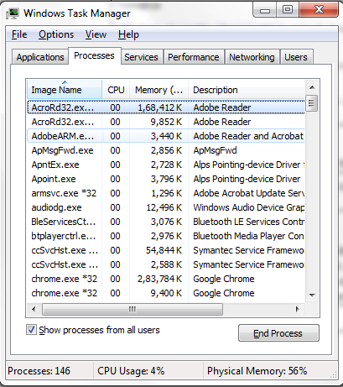

step 2) Click on View,
than on Select Option
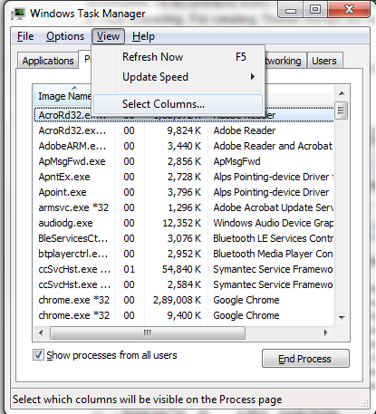

step 3) Check PID (Process Identifier)
than click Ok
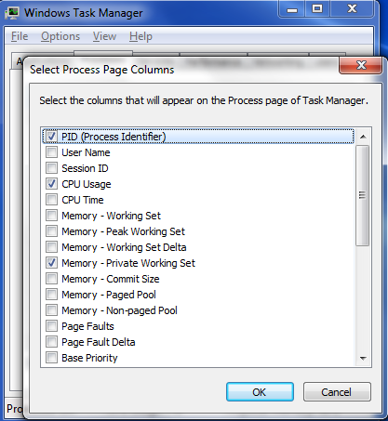

step 4) You will see a new column PID generated, select PID of javaw.exe i.e. Process identifier of java.
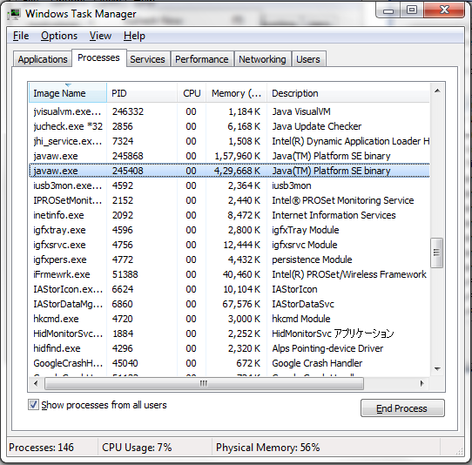

Now, comes the most important and interesting section - Creating Thread Dump using jstack and analyzing them.

Step 7) Go to CMD
And execute following commands :
cd C:\Program Files\Java\jdk1.7.0_51\bin
jstack.exe -l 245408 (where 245408 is PID)
And Thread Dump will be generated in cmd.

You may dump the generated Thread Dump in text file as well by using following command :
jstack.exe -l 245408 > ThreadDump.txt (where ThreadDump.txt will be created on path=C:\Program Files\Java\jdk1.7.0_51\bin)

Step 6) Please note : I have generated Thread dumps for following DeadLock program.

Executing the above command has generated Thread Dump for us.

Step 7) Further, we can analyze Thread Dump >
Before analyzing Thread dump, we must know Few Terminology used, which will help us in analyzing Thread dumps in comprehensive manner >

- Thread Dump : Thread gives complete information of threads created in our program and state transition of Threads. i.e. from new to dead state.

- Thread Name : Name of the Thread.

Extract taken from Thread dump (It gives complete information about thread, i have highlighted specific field) :
"RMI TCP Connection(3)-10.175.2.71" daemon prio=6 tid=0x0000000011459000 nid=0x3bf4c runnable [0x00000000120ef000]

- Thread States (java.lang.Thread.State) : States of Thread NEW, RUNNABLE, BLOCKED, WAITING, TIMED_WAITING and TERMINATED.
Extract taken from Thread dump (It gives complete information about thread, i have highlighted specific field) :
"RMI TCP Connection(3)-10.175.2.71" daemon prio=6 tid=0x0000000011459000 nid=0x3bf4c runnable [0x00000000120ef000]

- Thread Priority : Priority of the thread can be between 1 to 10, where 1 is MIN_PRIORITY and 10 is MAX_PRIORITY.
Extract taken from Thread dump (It gives complete information about thread, i have highlighted specific field) :
"RMI TCP Connection(3)-10.175.2.71" daemon prio=6 tid=0x0000000011459000 nid=0x3bf4c runnable [0x00000000120ef000]

- tid (Thread id) : Every thread is assigned a unique id. We can get this id by calling Thread.getId() method.
Extract taken from Thread dump (It gives complete information about thread, i have highlighted specific field) :
"RMI TCP Connection(3)-10.175.2.71" daemon prio=6 tid=0x0000000011459000 nid=0x3bf4c runnable [0x00000000120ef000]

- nid (Native thread id) : It gives us information about which thread is consuming most of CPU.
Extract taken from Thread dump (It gives complete information about thread, i have highlighted specific field) :
"RMI TCP Connection(3)-10.175.2.71" daemon prio=6 tid=0x0000000011459000 nid=0x3bf4c runnable [0x00000000120ef000]

- daemon : Tells whether thread is daemon or not.
Extract taken from Thread dump (It gives complete information about thread, i have highlighted specific field) :
"RMI TCP Connection(3)-10.175.2.71" daemon prio=6 tid=0x0000000011459000 nid=0x3bf4c runnable [0x00000000120ef000]

- Java stack information for the threads : It gives us complete information about threads state, one should observe them carefully for detecting line numbers which are responsible for deadlock deadlock formation.

"Thread-2":
at p13_0_createDeadlock.B.run(DeadlockCreation.java:43)
- waiting to lock <0x00000007ab2009a0> (a java.lang.Class for java.lang.String)
- locked <0x00000007ab2007e0> (a java.lang.Class for java.lang.Object)
at java.lang.Thread.run(Unknown Source)
"Thread-1":
at p13_0_createDeadlock.A.run(DeadlockCreation.java:18)
- waiting to lock <0x00000007ab2007e0> (a java.lang.Class for java.lang.Object)
- locked <0x00000007ab2009a0> (a java.lang.Class for java.lang.String)
at java.lang.Thread.run(Unknown Source)

- Finalizer : Gives information about reference objects. Reference objects are implemented in close cooperation with the garbage collector. It helps in freeing memory.

"Finalizer" daemon prio=8 tid=0x000000000f6a2000 nid=0x3bfc0 in Object.wait() [0x0000000010b9e000]
java.lang.Thread.State: WAITING (on object monitor)

- Reference Handler : It allows high-priority thread to execute after completion of previously queued threads i.e. high-priority thread to enqueue pending References.
"Reference Handler" daemon prio=10 tid=0x000000000f69a800 nid=0x3c0b8 in Object.wait() [0x000000001094f000]

- VM Thread : This thread is managed internally by hotspot VM.
"VM Thread" prio=10 tid=0x000000000f697000 nid=0x3c0d8 runnable

- GC task thread : These threads are responsible for garbage collection.

"GC task thread#0 (ParallelGC)" prio=6 tid=0x000000000230c800 nid=0x3c078 runnable
"GC task thread#1 (ParallelGC)" prio=6 tid=0x000000000230e000 nid=0x3c070 runnable
"GC task thread#2 (ParallelGC)" prio=6 tid=0x000000000230f800 nid=0x390f4 runnable
"GC task thread#3 (ParallelGC)" prio=6 tid=0x0000000002311800 nid=0x3b5f0 runnable

- VM Periodic Task Thread : This thread is managed internally by hotspot VM.
"VM Periodic Task Thread" prio=10 tid=0x000000000f71c000 nid=0x3bd30 waiting on condition

- JNI global references : It gives us count of number of objects which have live reference available to them in our java code. If object does not have any live reference available to it than that object’s count is not counted in JNI global reference and object is available for garbage collection.
JNI global references: 232

complete logs generated >
Now, I have mentioned complete logs generated. It shows us in detail that how threads went from RUNNING to WAITING state and then stayed in Waiting state. I have highlighted few important states of Thread, which will help you in analyzing logs very quickly.
2015-02-27 17:15:55
Full thread dump Java HotSpot(TM) 64-Bit Server VM (24.51-b03 mixed mode):
"RMI TCP Connection(3)-10.175.2.71" daemon prio=6 tid=0x0000000011459000 nid=0x3bf4c runnable [0x00000000120ef000]
java.lang.Thread.State: RUNNABLE
at java.net.SocketInputStream.socketRead0(Native Method)
at java.net.SocketInputStream.read(Unknown Source)
at java.net.SocketInputStream.read(Unknown Source)
at java.io.BufferedInputStream.fill(Unknown Source)
at java.io.BufferedInputStream.read(Unknown Source)
- locked <0x00000007ae2a74a0> (a java.io.BufferedInputStream)
at java.io.FilterInputStream.read(Unknown Source)
at sun.rmi.transport.tcp.TCPTransport.handleMessages(Unknown Source)
at sun.rmi.transport.tcp.TCPTransport$ConnectionHandler.run0(Unknown Source)
at sun.rmi.transport.tcp.TCPTransport$ConnectionHandler.run(Unknown Source)
at java.util.concurrent.ThreadPoolExecutor.runWorker(Unknown Source)
at java.util.concurrent.ThreadPoolExecutor$Worker.run(Unknown Source)
at java.lang.Thread.run(Unknown Source)
Locked ownable synchronizers:
- <0x00000007abb0c600> (a java.util.concurrent.ThreadPoolExecutor$Worker)
"RMI TCP Connection(idle)" daemon prio=6 tid=0x0000000011766000 nid=0x3c150 waiting on condition [0x0000000012dff000]
java.lang.Thread.State: TIMED_WAITING (parking)
at sun.misc.Unsafe.park(Native Method)
- parking to wait for <0x00000007aba016c0> (a java.util.concurrent.SynchronousQueue$TransferStack)
at java.util.concurrent.locks.LockSupport.parkNanos(Unknown Source)
at java.util.concurrent.SynchronousQueue$TransferStack.awaitFulfill(Unknown Source)
at java.util.concurrent.SynchronousQueue$TransferStack.transfer(Unknown Source)
at java.util.concurrent.SynchronousQueue.poll(Unknown Source)
at java.util.concurrent.ThreadPoolExecutor.getTask(Unknown Source)
at java.util.concurrent.ThreadPoolExecutor.runWorker(Unknown Source)
at java.util.concurrent.ThreadPoolExecutor$Worker.run(Unknown Source)
at java.lang.Thread.run(Unknown Source)
Locked ownable synchronizers:
- None
"JMX server connection timeout 17" daemon prio=6 tid=0x000000001169e000 nid=0x3c2c4 in Object.wait() [0x00000000124cf000]
java.lang.Thread.State: TIMED_WAITING (on object monitor)
at java.lang.Object.wait(Native Method)
- waiting on <0x00000007abddcff8> (a [I)
at com.sun.jmx.remote.internal.ServerCommunicatorAdmin$Timeout.run(Unknown Source)
- locked <0x00000007abddcff8> (a [I)
at java.lang.Thread.run(Unknown Source)
Locked ownable synchronizers:
- None
"RMI Scheduler(0)" daemon prio=6 tid=0x000000001154f000 nid=0x3bef0 waiting on condition [0x00000000123ce000]
java.lang.Thread.State: TIMED_WAITING (parking)
at sun.misc.Unsafe.park(Native Method)
- parking to wait for <0x00000007aba19138> (a java.util.concurrent.locks.AbstractQueuedSynchronizer$ConditionObject)
at java.util.concurrent.locks.LockSupport.parkNanos(Unknown Source)
at java.util.concurrent.locks.AbstractQueuedSynchronizer$ConditionObject.awaitNanos(Unknown Source)
at java.util.concurrent.ScheduledThreadPoolExecutor$DelayedWorkQueue.take(Unknown Source)
at java.util.concurrent.ScheduledThreadPoolExecutor$DelayedWorkQueue.take(Unknown Source)
at java.util.concurrent.ThreadPoolExecutor.getTask(Unknown Source)
at java.util.concurrent.ThreadPoolExecutor.runWorker(Unknown Source)
at java.util.concurrent.ThreadPoolExecutor$Worker.run(Unknown Source)
at java.lang.Thread.run(Unknown Source)
Locked ownable synchronizers:
- None
"RMI TCP Accept-0" daemon prio=6 tid=0x000000001167e000 nid=0x3c35c runnable [0x0000000011f4e000]
java.lang.Thread.State: RUNNABLE
at java.net.DualStackPlainSocketImpl.accept0(Native Method)
at java.net.DualStackPlainSocketImpl.socketAccept(Unknown Source)
at java.net.AbstractPlainSocketImpl.accept(Unknown Source)
at java.net.PlainSocketImpl.accept(Unknown Source)
- locked <0x00000007aba27808> (a java.net.SocksSocketImpl)
at java.net.ServerSocket.implAccept(Unknown Source)
at java.net.ServerSocket.accept(Unknown Source)
at sun.management.jmxremote.LocalRMIServerSocketFactory$1.accept(Unknown Source)
at sun.rmi.transport.tcp.TCPTransport$AcceptLoop.executeAcceptLoop(Unknown Source)
at sun.rmi.transport.tcp.TCPTransport$AcceptLoop.run(Unknown Source)
at java.lang.Thread.run(Unknown Source)
Locked ownable synchronizers:
- None
"DestroyJavaVM" prio=6 tid=0x000000000078e000 nid=0x3b95c waiting on condition [0x0000000000000000]
java.lang.Thread.State: RUNNABLE
Locked ownable synchronizers:
- None
"Thread-2" prio=6 tid=0x0000000011451800 nid=0x3bb00 waiting for monitor entry [0x000000001082f000]
java.lang.Thread.State: BLOCKED (on object monitor)
at p13_0_createDeadlock.B.run(DeadlockCreation.java:43)
- waiting to lock <0x00000007ab2009a0> (a java.lang.Class for java.lang.String)
- locked <0x00000007ab2007e0> (a java.lang.Class for java.lang.Object)
at java.lang.Thread.run(Unknown Source)
Locked ownable synchronizers:
- None
"Thread-1" prio=6 tid=0x0000000011451000 nid=0x3bf88 waiting for monitor entry [0x000000001196f000]
java.lang.Thread.State: BLOCKED (on object monitor)
at p13_0_createDeadlock.A.run(DeadlockCreation.java:18)
- waiting to lock <0x00000007ab2007e0> (a java.lang.Class for java.lang.Object)
- locked <0x00000007ab2009a0> (a java.lang.Class for java.lang.String)
at java.lang.Thread.run(Unknown Source)
Locked ownable synchronizers:
- None
"Service Thread" daemon prio=6 tid=0x000000000f70b800 nid=0x3b9fc runnable [0x0000000000000000]
java.lang.Thread.State: RUNNABLE
Locked ownable synchronizers:
- None
"C2 CompilerThread1" daemon prio=10 tid=0x000000000f707800 nid=0x3ba38 waiting on condition [0x0000000000000000]
java.lang.Thread.State: RUNNABLE
Locked ownable synchronizers:
- None
"C2 CompilerThread0" daemon prio=10 tid=0x000000000f703000 nid=0x3b918 waiting on condition [0x0000000000000000]
java.lang.Thread.State: RUNNABLE
Locked ownable synchronizers:
- None
"Attach Listener" daemon prio=10 tid=0x000000000f6fd800 nid=0x3c104 waiting on condition [0x0000000000000000]
java.lang.Thread.State: RUNNABLE
Locked ownable synchronizers:
- None
"Signal Dispatcher" daemon prio=10 tid=0x000000000f6f6000 nid=0x3bb18 runnable [0x0000000000000000]
java.lang.Thread.State: RUNNABLE
Locked ownable synchronizers:
- None
"Finalizer" daemon prio=8 tid=0x000000000f6a2000 nid=0x3bfc0 in Object.wait() [0x0000000010b9e000]
java.lang.Thread.State: WAITING (on object monitor)
at java.lang.Object.wait(Native Method)
- waiting on <0x00000007ab205568> (a java.lang.ref.ReferenceQueue$Lock)
at java.lang.ref.ReferenceQueue.remove(Unknown Source)
- locked <0x00000007ab205568> (a java.lang.ref.ReferenceQueue$Lock)
at java.lang.ref.ReferenceQueue.remove(Unknown Source)
at java.lang.ref.Finalizer$FinalizerThread.run(Unknown Source)
Locked ownable synchronizers:
- None
"Reference Handler" daemon prio=10 tid=0x000000000f69a800 nid=0x3c0b8 in Object.wait() [0x000000001094f000]
java.lang.Thread.State: WAITING (on object monitor)
at java.lang.Object.wait(Native Method)
- waiting on <0x00000007ab2050f0> (a java.lang.ref.Reference$Lock)
at java.lang.Object.wait(Object.java:503)
at java.lang.ref.Reference$ReferenceHandler.run(Unknown Source)
- locked <0x00000007ab2050f0> (a java.lang.ref.Reference$Lock)
Locked ownable synchronizers:
- None
"VM Thread" prio=10 tid=0x000000000f697000 nid=0x3c0d8 runnable
"GC task thread#0 (ParallelGC)" prio=6 tid=0x000000000230c800 nid=0x3c078 runnable
"GC task thread#1 (ParallelGC)" prio=6 tid=0x000000000230e000 nid=0x3c070 runnable
"GC task thread#2 (ParallelGC)" prio=6 tid=0x000000000230f800 nid=0x390f4 runnable
"GC task thread#3 (ParallelGC)" prio=6 tid=0x0000000002311800 nid=0x3b5f0 runnable
"VM Periodic Task Thread" prio=10 tid=0x000000000f71c000 nid=0x3bd30 waiting on condition
JNI global references: 232
Found one Java-level deadlock:
=============================
"Thread-2":
waiting to lock monitor 0x000000000f6a0388 (object 0x00000007ab2009a0, a java.lang.Class),
which is held by "Thread-1"
"Thread-1":
waiting to lock monitor 0x000000000f6a1828 (object 0x00000007ab2007e0, a java.lang.Class),
which is held by "Thread-2"
Java stack information for the threads listed above:
===================================================
"Thread-2":
at p13_0_createDeadlock.B.run(DeadlockCreation.java:43)
- waiting to lock <0x00000007ab2009a0> (a java.lang.Class for java.lang.String)
- locked <0x00000007ab2007e0> (a java.lang.Class for java.lang.Object)
at java.lang.Thread.run(Unknown Source)
"Thread-1":
at p13_0_createDeadlock.A.run(DeadlockCreation.java:18)
- waiting to lock <0x00000007ab2007e0> (a java.lang.Class for java.lang.Object)
- locked <0x00000007ab2009a0> (a java.lang.Class for java.lang.String)
at java.lang.Thread.run(Unknown Source)
Found 1 deadlock.

Application of jtack>
jstack can be very handy in detecting Deadlocks in multithreaded programs.

Heap Dump

Overview
Identifying the reason for an OutOfMemory error in Java applications with a larger heap size is a nightmare for a developer, because most of the OutOfMemory situations may not be identified during the testing phase. It may occur only in production after running for a long time. The purpose of this article is to explain the use of a heap analyzer tool to identify a memory leakage in larger enterprise Java applications, which use a larger size of heaps. Before going to the details, we will discuss the following points:
- Heap
- Garbage Collection
- OutOfMemory

What Is Heap?
The space used by the Java Runtime to allocate memory to Objects and JRE Classes is called Heap. The heap space can be configured using the following JVM arguments:
- -Xmx<size> — Setting maximum Java heap size
- -Xms<size> — Setting initial Java heap size
The maximum heap size that can be configured in a 32 bit JVM is 2GB. If any application requires more than 2 GB, it should run on 64 bit JVM. 64MB is the maximum heap size by default.

Garbage Collection
One of the advantages of Java over C++ is automatic memory management. In C++, memory can be released manually, but it will happen automatically in Java using a process called garbage collection. Garbage collection will free up the memory of an object that doesn’t have any reference; it will destroy unused objects. The garbage collection process can be tuned for different applications based on the object creation characteristics of the application. This can be achieved through a number of JVM arguments. Following are a few JVM arguments which can be used to tune the garbage collection process:
Option | Description
-XX:-UseParallelGC | Use parallel garbage collection for scavenges.
-XX:-UseParallelOldGC | Use parallel garbage collection for the full collections. Enabling this option automatically sets -XX:+UseParallelGC.
-XX:NewRatio | Ratio of old/new generation sizes. The default value is 2.
-XX:SurvivorRatio | Ratio of eden/survivor space size. The default value is 8.
-XX:ParallelGCThreads | Sets the number of threads used during parallel phases of the garbage collectors. The default value varies with the platform on which the JVM is running
GC Execution has a direct relationship with the size of the Heap.
- Larger Heap size will increase the GC execution time, but decrease the number of GC executions.
- Smaller Heap Size will increase the number of GC executions, but decrease the GC execution time

OutOfMemory
A java.lang.OutOfMemoryError will occur when the application tries to add more objects into the heap and there is no space left. This will happen when the maximum heap size set in the start of the application is filled with objects and the garbage collector is not able to free up the memory because the all objects in heap still have some references. This may happen because of two reasons:
- The application may need more memory to run; the currently allocated heap size is not enough to accommodate the objects generated during the runtime.
- Due to a coding error in the application which is keeping the references of unwanted objects.
The solution for the first reason is to increase the heap size. The solution for the second is to analyze the code flow and heap dump to identify the unwanted objects in heap. To analyze the application heap, we need to take the heap dump and open it in a memory analyzing tool.
In this article, we will discuss on how to take the heap dump of an application running on Oracle Java and analyze it in Eclipse Memory Analyzer.

How to Take Heap Dump
Heap dump can be taken in two ways:
- A JVM argument can be added to generate heap dump whenever an OutOfMemoryError occurs.
The -XX:+HeapDumpOnOutOfMemoryError option can be added to generate a heap dump on OutOfMemoryError. By default, the heap dump is created in a file called java_pid pid .hprof in the working directory of the VM, but we can set an alternative path using the JVM option -XX:HeapDumpPath=path.
- Using a jmap tool available with JDK. The following command can be executed from the command line:
jmap -dump:format=b,file=heap.bin <pid>
"<pid>" can be replaced with the process id of the application.

Eclipse Memory Analyzer
Eclipse Memory Analyzer can download from eclipse.org.
Unzip the downloaded file and double click "MemoryAnalyzer" to start the application.
Execute a Java program which is continuously running.
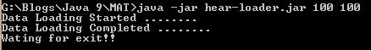
Take heap dump using jmap:
jmap -dump:format=b,file=heap.bin 6920
Identify the process id of the running application in Windows from the Task Manager.
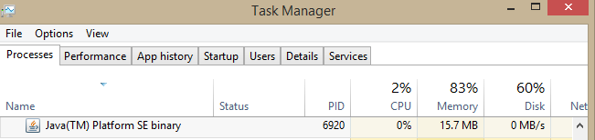
In Linux, to identify the process id, use ps –ef | grep java.
Open the heap dump in Eclipse Memory Analyzer using the option File --> Open Heap Dump.
First, it will prompt you to create a leak suspect report. The user can create it or skip it.
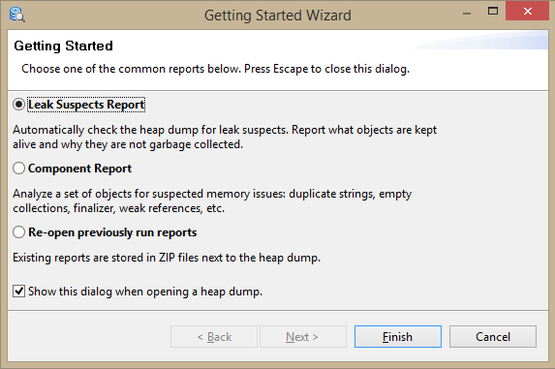
The "overview" tab of the memory analyzer will show the total size of the heap and a pie chart of object size.
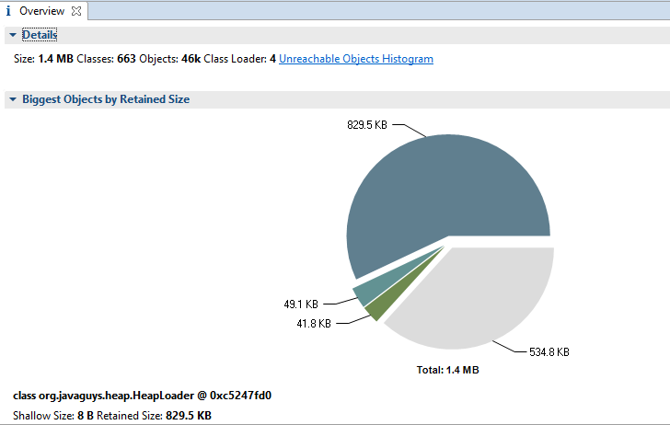
Click on the highest value in the pie chart and select List Objects --> with outgoing references.
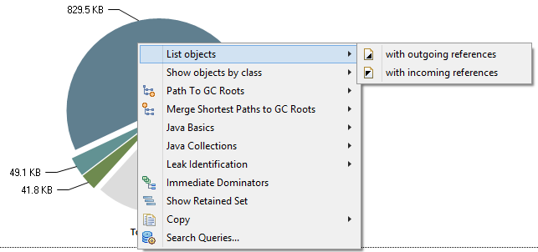
It will open a new tab, "List Objects," and expand the tree structure of the object.
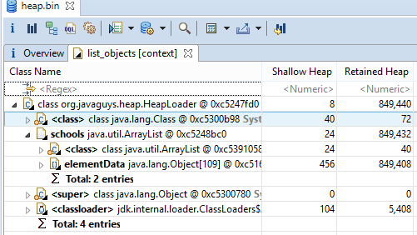
The user can expand and find the objects available in heap. In this example, the HeapLoader object consist of a list of School objects, and school objects consist of a list of students.
School List in HeapLoader
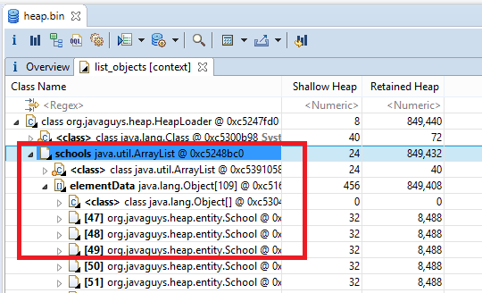
Each school object in List and its attributes
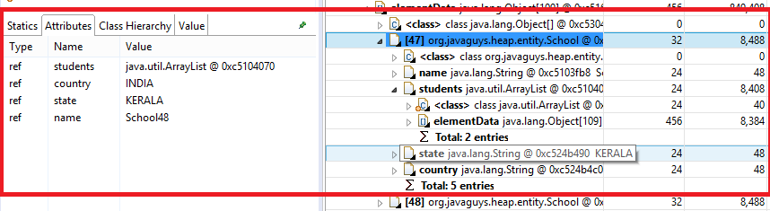
Student object in school and its attribute
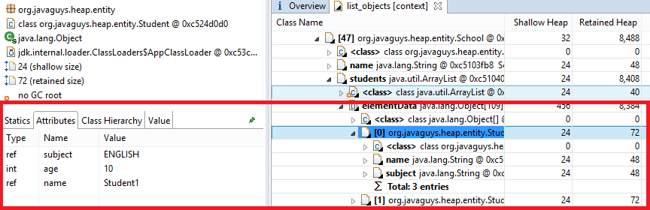
There is an option available in Eclipse Memory Analyzer to Acquire Heap Dump if the application is running on the same machine. SelectFile --> Acquire Heap Dump to show all Java applications available on the machine. Select the process, browse the path where you want the heap to save. and click "finish."
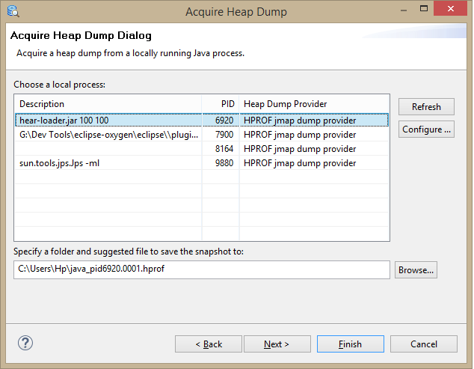
These are the basic steps to analyze a heap dump. There are more options available in Memory Analyzer, which will give more insight into the heap dump. Eclipse Heap Analyzer can be used for the dumps generated from an application running on Oracle Java.

